**R ASSIGNMENT 5**

#Q1

print(punif(45, min = 0, max = 60, log = FALSE,lower.tail = FALSE))

print(punif(30, min = 0, max = 60) - punif(20, min = 0, max = 60))

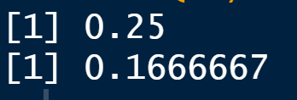

# Q2A

print(dexp(3, rate = 1/2))



#Q2B

plot(dexp(5, rate = 1/2)-pexp(0,rate=1/2) )

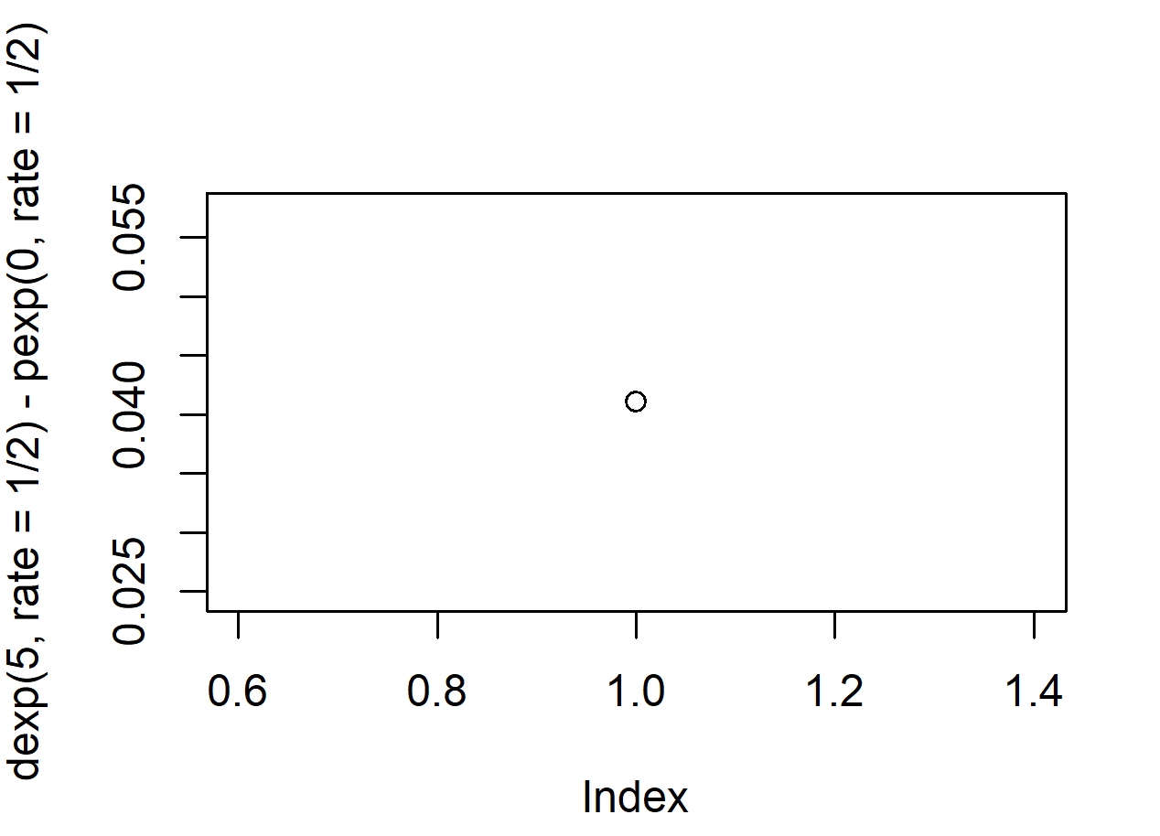

#Q2C

print(1-pexp(3, rate = 1/2,lower.tail=FALSE))



#Q2D

plot(pexp(seq(0,5), rate = 1/2))

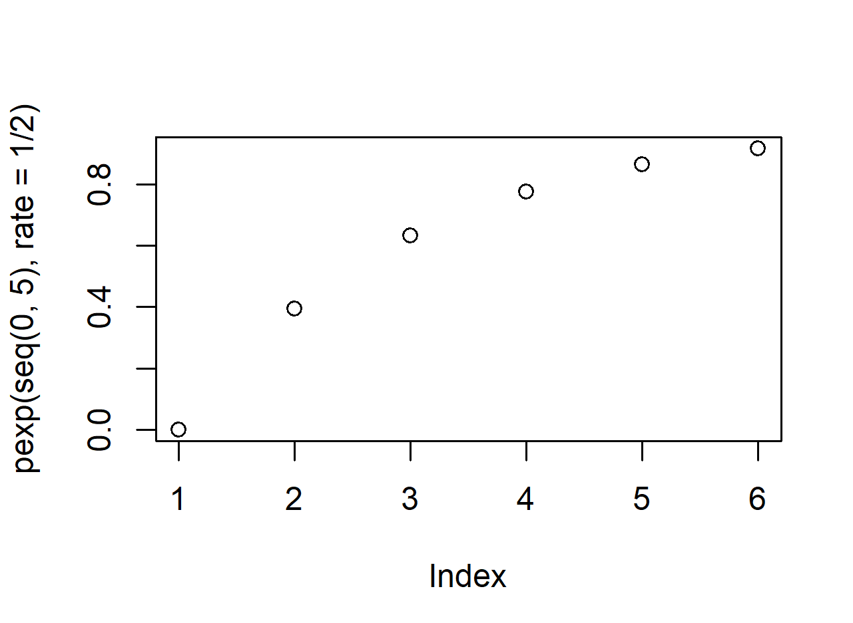

#Q2E

plot(pexp(seq(0,5,by=.0005), rate = 1/2))

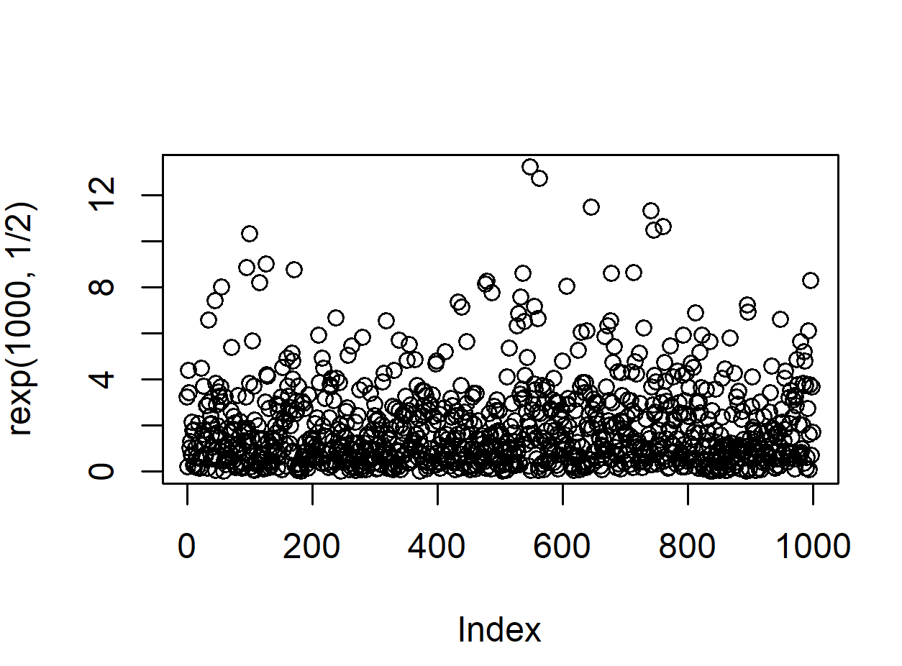

#Q3Ai

print(dgamma(3, shape = 2, scale = 1/3))



#Q3Aii

print(1-pgamma(q = 1, shape = 2, scale = 1/3))



#Q3B

print(qgamma(0.70, shape=2, scale=1/3, lower.tail = TRUE,log.p = FALSE))

